TAVI – Circulating Nurse Responsibilities

Pre-Patient Arrival

- Arrange furniture in the room (see picture)
- Set up the med-rad
- Make 3 bags of Heparinized-saline for flush and label the bags

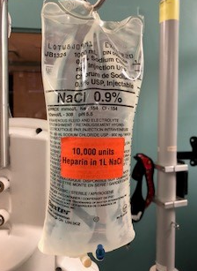

On Patient Arrival
- Patient will be given conscious sedation only (unless otherwise discussed)
- Defibrillator pads positioned under each axilla (the traditional positioning shows under x-ray). Connect Defibrillator pads before the start of the case
- Cautery pad on buttock or arm (used only as backup)
- Check pedal pulses and mark to determine changes post procedure (Fellow to-do)
- For radial approach, right arm extended on arm board - Palm up
- Tuck left arm
- Position patients feet hip distance apart to aid in access, blanket on lower legs
- Fellow will prep skin from collar bone to knees
- Nurse to hold up the patients right arm for draping
- No Foley catheter needed
**Ensure that pump eligibility is discussed during the time out **

Intra-op

- Call for the patients bed depending on where the patient is going post-op (check list)
- Be at the defibrillator for rapid pacing as defibrillation may be needed after
- Prep next case cart and prepare Heparinized-saline flush for next case
- Pick all TAVI items from TAVI Pyxis
- Once the valve is deployed call TL to confirm we can proceed with next patient, then call for lines for the next patient
- Call post-op location when valve is deployed to confirm room and give the nurse report
- Fill out TAVI handover tool (see documentation section)
- Refer to documentation section for documentation tips (valve, medication etc…)

Post-op

- Open a TR band at the end of the case. Place the syringe in bag in labeled bag in patients chart. Char the amount of air used on the Handover tool
- Clean and dry groin
- Apply opsites as needed
- Call attendant once the opsites are on patient
- Transfer patient to post-op location with monitor

